GUI-BASED MUSIC LIBRARY ORGANISER

INTRODUCTION:

The GUI-Based Music Library Organizer is a desktop application designed to help users efficiently manage and organize their personal music collections through an easy-to-use graphical interface. With the rapid growth of digital music, users often struggle to keep track of large numbers of audio files scattered across different folders and devices. This application provides a centralized platform where users can add, view, sort, search, and categorize their songs conveniently.

Built with a Graphical User Interface (GUI), the system eliminates the complexity of command-line tools and provides an intuitive experience for users of all technical levels. Features such as playlist creation, metadata display (title, artist, album, genre, duration), and file management make it easier to browse and play music efficiently.

The project aims to demonstrate practical use of GUI programming concepts, event handling, and file management in a real-world application. Technologies such as JavaFX, Swing, or Python Tkinter (depending on implementation) can be used to build the interface, while object-oriented programming principles ensure modularity and scalability.

PROJECT DESCRIPTION:

The GUI-Based Music Library Organizer is a desktop application designed to help users manage, organize, and access their music files easily through an interactive graphical interface. The main goal of this project is to provide an efficient way to store and retrieve music information without the need to browse through multiple folders manually.

The system allows users to add new songs, edit song details, delete unwanted tracks, and search or sort their collection based on attributes such as title, artist, album, or genre. It can also display metadata such as duration, file type, and file location. The application’s GUI ensures a user-friendly experience where all operations can be performed using buttons, menus, and dialog boxes rather than command-line inputs.

The project demonstrates the use of GUI frameworks (such as JavaFX or Swing), event handling, file handling, and object-oriented programming concepts. It combines design and logic to showcase how software applications can enhance the way users interact with digital media libraries.

SYSTEM ARCHITECTURE:

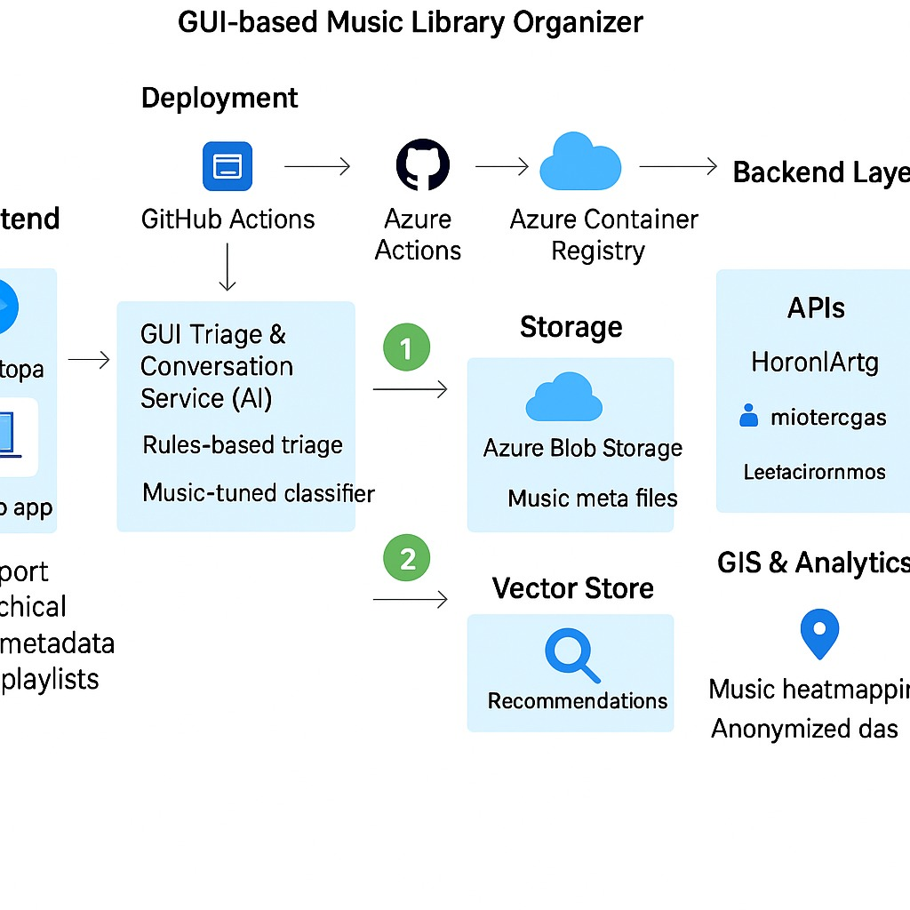

PROGRAM:

import javax.swing.*;
import javax.swing.table.DefaultTableModel;
import java.awt.*;
import java.awt.event.*;

public class MusicLibraryOrganizer {

public static void main(String[] args) {
// Frame setup
JFrame frame = new JFrame("Music Library Organizer");
frame.setSize(700, 400);
frame.setDefaultCloseOperation(JFrame.EXIT_ON_CLOSE);

// Table model and table
String[] columns = {"Title", "Artist", "Album", "Genre"};
DefaultTableModel model = new DefaultTableModel(columns, 0);
JTable table = new JTable(model);
JScrollPane scrollPane = new JScrollPane(table);

// Input fields
JTextField titleField = new JTextField(10);
JTextField artistField = new JTextField(10);
JTextField albumField = new JTextField(10);
JTextField genreField = new JTextField(10);

// Buttons
JButton addButton = new JButton("Add Song");
JButton deleteButton = new JButton("Delete Song");

// Panel for inputs
JPanel inputPanel = new JPanel();
inputPanel.add(new JLabel("Title:"));
inputPanel.add(titleField);
inputPanel.add(new JLabel("Artist:"));
inputPanel.add(artistField);
inputPanel.add(new JLabel("Album:"));
inputPanel.add(albumField);
inputPanel.add(new JLabel("Genre:"));
inputPanel.add(genreField);
inputPanel.add(addButton);
inputPanel.add(deleteButton);

// Add song button action
addButton.addActionListener(e -> {
String title = titleField.getText();
String artist = artistField.getText();
String album = albumField.getText();
String genre = genreField.getText();

if (title.isEmpty() || artist.isEmpty()) {
JOptionPane.showMessageDialog(frame, "Please enter at least Title and Artist!");
return;
}

model.addRow(new Object[]{title, artist, album, genre});
titleField.setText("");
artistField.setText("");
albumField.setText("");
genreField.setText("");
});

// Delete song button action
deleteButton.addActionListener(e -> {
int selectedRow = table.getSelectedRow();
if (selectedRow >= 0) {
model.removeRow(selectedRow);
} else {
JOptionPane.showMessageDialog(frame, "Please select a song to delete!");
}
});

// Layout
frame.setLayout(new BorderLayout());
frame.add(scrollPane, BorderLayout.CENTER);
frame.add(inputPanel, BorderLayout.SOUTH);

// Show window
frame.setVisible(true);
}
}

OUTPUT:

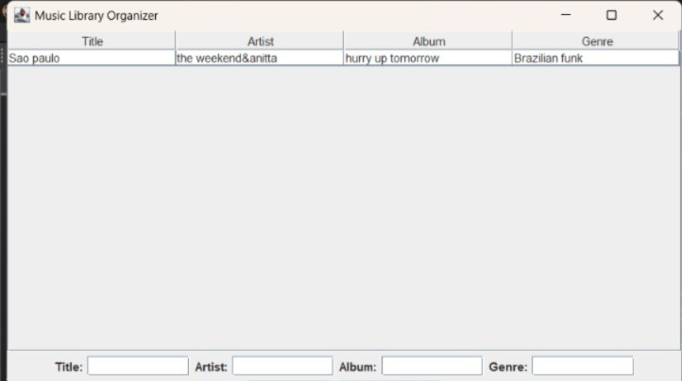

CONCLUSION AND FUTURE WORK:

CONCLUSION:

The GUI-Based Music Library Organizer successfully provides an easy and user-friendly way to manage and organize music collections. The application allows users to add, view, and delete songs conveniently using a graphical interface. By implementing this system, users can keep track of their favorite music in one place without manually browsing through folders.

This project demonstrates the practical use of Java GUI programming (Swing/JavaFX) and object-oriented programming concepts such as classes, objects, and event handling. It also enhances understanding of how to create real-world applications with interactive components. Overall, the project meets its objective of simplifying music organization through an efficient, attractive, and intuitive interface.

FUTURE WORK:
Although the current version performs basic operations efficiently, there is scope for several enhancements in the future, such as:

🎵 Music Playback:
Add an audio player feature to play selected songs directly from the application.

💾 File Storage:
Enable saving and loading of the music library data to/from a text file or database, so songs are retained after closing the program.

🔍 Search and Filter:
Implement search and sorting options by title, artist, genre, or album to make navigation faster.

🎨 Improved Interface:
Enhance the design using JavaFX with modern UI elements, icons, and themes for better user experience.
PSO MAPPING:

Course Outcomes / Project Activities | PO1 | PO2 | PO3 | PO4 | PO5 | PO6 | PO7 | PO8 | PO9 | PO10 | PO11 | PO12 | PSO1 | PSO2 | PSO3
GUI-based application design using Java (Swing/JavaFX) | 3 | 3 | 2 | 2 | 3 | 1 | 1 | 1 | 2 | 3 | 1 | 1 | 3 | 3 | 2
Implementation of Object-Oriented Programming principles | 3 | 3 | 3 | 2 | 2 | 1 | 1 | 1 | 2 | 2 | 1 | 1 | 3 | 3 | 2
Development of user-friendly interface | 2 | 2 | 2 | 2 | 3 | 1 | 1 | 2 | 3 | 3 | 1 | 1 | 2 | 3 | 2
Testing, debugging, and documentation | 2 | 3 | 3 | 2 | 2 | 1 | 1 | 1 | 2 | 3 | 2 | 2 | 3 | 2 | 2
Understanding software design and modularity | 3 | 3 | 3 | 2 | 2 | 1 | 1 | 1 | 2 | 2 | 1 | 2 | 3 | 3 | 2

RATING SCALE:
Rating | Meaning
1 | Low correlation / contribution
2 | Moderate correlation / contribution
3 | High correlation / contribution

